Currency Power
http://translate.google.com/translate?hl=en&js=n&u=http://forextools.com.ua&sl=ru&tl=en

Intra-day trading requires a very aggressive tactics of behavior in the market. It is necessary to quickly assess the current situation so as not to miss the slightest opportunity to make faster and more. In this mode, it is important to be able to quickly and correctly choose a currency pair to trade with the greatest possible potential for profit. Unfortunately, the terminal MT4 provides very little foundation for such work. You can certainly open the windows of dozens of different currency pairs and add them to at least one MA and arranging all the tiles of the schedule, as the cells in the comb, while watching them and select the most suitable. However, the screen - not the rubber, and the speed of analysis of such an array of visual information is not very large. The number of currency pairs in the tens. The number of currencies involved in the construction of the currency pairs in the order of magnitude smaller. Each of them has a specific point in time when it shows "strength." For example, the euro could begin to rapidly fall in price, the franc after him, too, began to fall softly, and the dollar - slowly begins to rise. If one of these three possible pairs of currencies to collect, we can expect the following results: a strong drop in EURUSD and EURCHF drop weaker and USDCHF. What kind of currency pair(s) to trade? Of course the one which has more traffic! The question is how to calculate?

Let's look at the situation a little differently. Take, for example, a pair EURUSD. If the price rose by 10 points then we can say that the euro went up by 10 points, and the dollar fell by the same 10 points. That is, for EUR to increase by10, USD must fell by 10. But just as well, if you take a couple of USDCHF, the price of which, for example, fell by 5 points, we can say that the dollar it has grown in strength by 5 points. Thus we have for USD -10 (on EURUSD) and 5 (from CHFUSD). I guess we can say that the total force amounted to USD -5 points. Of course, this is not absolutely accurate measurement, but in such a formulation of the problem a qualitative indicator of the abstract concept of "power exchange" takes on a quantitative measurement that allows comparison between different pairs.

If we take the price increase for several currency pairs, and assume that the increase in the price increase strength of the first currency in the pair, and the corresponding weakening of the strength of the second currency in the pair, we get the opportunity to choose the currency pair with the very highest earning potential - a pair of maximum growth first currency in the pair and the maximum force of the fall of the second currency in the pair.

It is for this algorithm works display ft.CurrencyPower. You specify the parameters display the names of currencies that you want to analyze. Indicator itself is all possible combinations of currency pairs, calculates the strength of each currency and it determines the strength of each currency pair and its direction - buying or selling.

The appearance of the indicator
The screen display is nothing superfluous: the first few graphs of the forces of exchange list in the upper right corner - the figures are the strength of each currency, and under them - the power of all currency pairs, consisting of the given currency, and the lists are grouped into two blocks (the buying and selling) in each of which currency pairs are arranged in descending order of their strength and decrease in proportion to force the pair decreases the saturation of colors: blue - for buying and red - for sale.

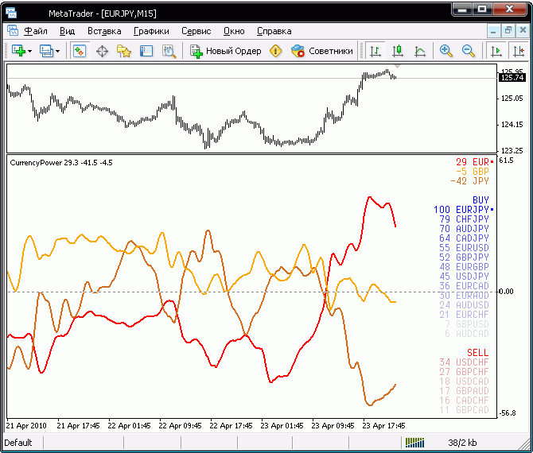

Thus, for the choice of the pair to trade, you simply select one of the first block of the purchase or sale, with the maximum rate of force. For ease of display, power rates are calculated in points of interest, where the maximum value corresponds to 100%. As you can see in the image below to purchase the maximum force has a pair of EURUSD, and on sale - USDCHF. However USDCHF strength nearly three times weaker than the EURUSD. Let's check if this is so, and compare these two graphs (EURUSD - at the top, USDCHF - below):

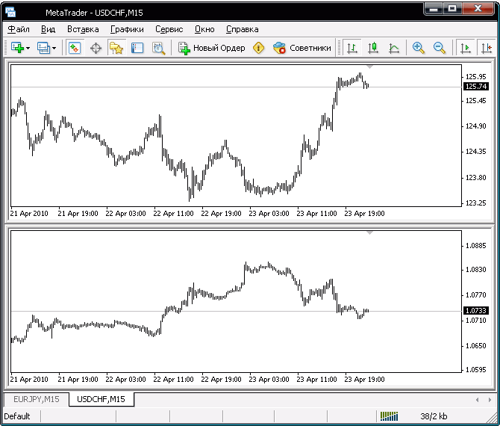

As we see, indeed, EURUSD really is steeper and therefore the possibility of earning on it may be more.
Here we should pay attention to one feature of the terminal and the indicator. The terminal can automatically select the scale of the chart so that the graph is stretched to the full height of the screen. As a result, the terminal two graphs can have virtually the same form of growth or decline rates, but the scale is completely different. In the above screenshot in both graphs the same vertical size in points - roughly 300 points. I had to specifically reduce the scale of the lower chart so they can be compared. If you do not, the picture will look like this:

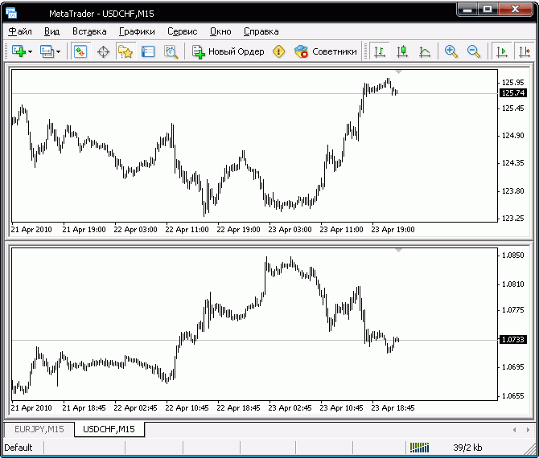
As you can see, visually, "the slope of the graphs," almost equal, but that is not so in the bottom of the graph vertically about 200 points, while the comrade at the top - nearly 300. That's how you can accidentally lose 100 points if the price move and you do correctly choose the right pair. The use of indicator ft.CurrencyPower frees you from such errors of analysis.

An indicator
CurrencyList - a list of currencies. It should consist of three-letter currency codes separated by a space. By default, the list of all the currencies that make up the pairs Oanda - EUR JPY GBP USD CHF CAD AUD. You can change it at their own discretion. When the indicator demorezhime used a fixed set of currencies (NZD CHF CAD AUD) is not the most optimal in terms of trade, but it gives the opportunity to evaluate the performance indicator in its entirety.
ShowFirst - number of first rate from the list that you want to show in graphs. They cannot be longer than 8 - this is the limitation of the platform MetaTrader. The number of exchange listed CurrencyList may be more than ShowFirstdlya to light more accurately identified using other currencies weight kroskursy.
PeriodMA - period moving average used to obtain the difference between the past and the current value of the price, which is used to calculate the forces of currencies. It is necessary to obtain a smoother schedule that more can be strengthened in the following parameter
Smooth - the period of additional smoothing schedules.
Color1-8 - the line color charts. They are assigned to the currencies of the order in which they are listed in the parameter CurrencyList.
Width - thickness of the lines of the graphs
FontName - print labels. To make the inscriptions "table" form it should be a fixed width font with characters such as CourierNew.
FontSize - font size for labels.
WidthScreens - the width of drawing graphs in the visible screen. Due to a very large amount of allocations for all currency pairs have to limit their amount of such an unconventional way.

Comments on the performance indicator
Due to the fact that the construction of an indicator to calculate a very large amount of data on a large number of currency pairs, their first appearance in the terminal may be delayed for a time from one to several minutes. This is due to the fact that in the calculation of exchange forces can be used by currency pair that you had not previously enjoyed. Therefore, the terminal needs some time to download all the necessary historical data for all currency pairs, which it builds on the basis of a list of CurrencyList. However, such a long delay is possible only for the first time when joining the indicator. Later, when the bulk of the data will already be downloaded, the update process will be virtually invisible.

To reduce the load on the CPU even more light pereschityvaestya once at the beginning of the current bar - in fact, at the closing price the previous bar. Most update it makes no sense, because it still is not designed to work "inside the bar." If you still want to update it more often - hang it on a graph with a minimum timeframe.

